25Q4 Enumeration of HTTP methods against Test and Dev Servers

Introduction:

Present within AVD

Table of Contents
Introduction: 2
25Q4 Enumeration of HTTP methods against Test and Dev Servers 4

25Q4 Enumeration of HTTP methods against Test and Dev Servers
Description

During testing, the target web application was assessed for supported HTTP methods. Standard HTTP verbs such as GET, POST, PUT, DELETE, PATCH, OPTIONS, HEAD, and TRACE were identified..

HTTP methods define the actions that can be performed on resources within a web application. While GET and POST are commonly used in normal application workflows, other methods such as PUT, DELETE, PATCH, OPTIONS, and TRACE may expose unintended functionality if not properly restricted. For example:

- PUT/DELETE could allow unauthorized modification or removal of resources.
- TRACE may enable cross-site tracing (XST) attacks, potentially leading to information disclosure.
- OPTIONS reveals supported methods, aiding attackers in reconnaissance.

Impact

If insecure or unnecessary methods are enabled, attackers may exploit them to:

- Manipulate or delete application data.
- Bypass access controls.
- Gather intelligence about server configuration.
- Conduct advanced attacks such as Cross-Site Tracing.
- Expected Responses from the web application

Method | Expected Response (Secure Application)
GET | Returns requested resource (200 OK) or error (404 Not Found if missing).
HEAD | Returns headers only (200 OK) without body.
POST | Creates or processes data; should return 201 Created or 200 OK.
PUT | Should be disabled unless explicitly required. If enabled, replaces resource and returns 200 OK/201 Created.
DELETE | Should be disabled unless explicitly required. If enabled, deletes resource and returns 200 OK/204 No Content.
PATCH | Should be disabled unless explicitly required. If enabled, partially updates resource and returns 200 OK.
OPTIONS | Returns list of allowed methods (200 OK with Allow header).
TRACE | Should be disabled. If enabled, echoes request (200 OK) which is a security risk.

Report when the following is found

- ✅ GET/POST/HEAD → Normal and expected; no issue if properly controlled.
- PUT/DELETE/PATCH → Report if enabled without authentication/authorization. These can allow attackers to modify or delete resources.
- OPTIONS → Report if it reveals sensitive or unnecessary methods. Developers should restrict the Allow header to only required methods.
- ❌ TRACE → Always report if enabled. It is rarely needed and can lead to Cross-Site Tracing (XST) attacks.

Steps

Start by sending TRCAE request using cURL. The following sample requests can be used

# 1. OPTIONS – Discover allowed methods
curl -i -X OPTIONS https://testportal.zalaris.com/

# 2. GET – Retrieve resource
curl -i -X GET https://testportal.zalaris.com/

# 3. HEAD – Retrieve headers only
curl -i -X HEAD https://testportal.zalaris.com/

# 4. POST – Submit data
curl -i -X POST https://testportal.zalaris.com/ -d "param1=value1&param2=value2"

# 5. PUT – Attempt to replace resource
curl -i -X PUT https://testportal.zalaris.com/ -d "This is test content"

# 6. DELETE – Attempt to delete resource
curl -i -X DELETE https://testportal.zalaris.com/

# 7. PATCH – Attempt partial update
curl -i -X PATCH https://testportal.zalaris.com/ -d '{"field":"newValue"}' -H "Content-Type: application/json"

# 8. TRACE – Debugging echo request
curl -i -X TRACE https://testportal.zalaris.com/

Supporting screenshots [Unauthenticated requests]

Targeted IP : 91.203.116.23

cURL request with OPTIONS method to discover allowed methods. No information on allowed methods is received in the response

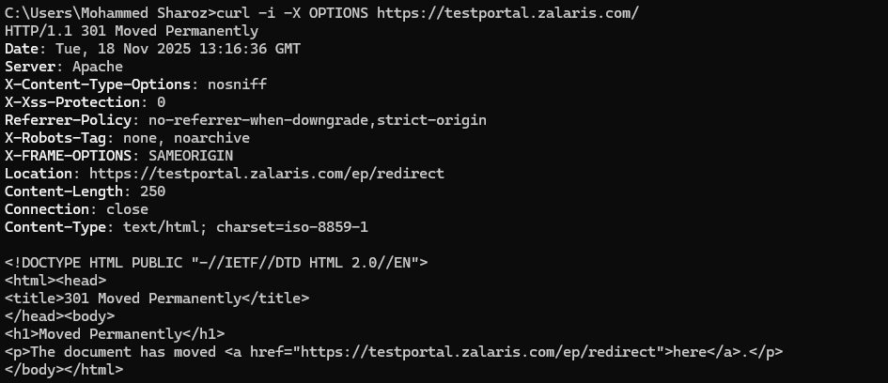

cURL GET request to retrieve resource. Received 301 Moved permanently response

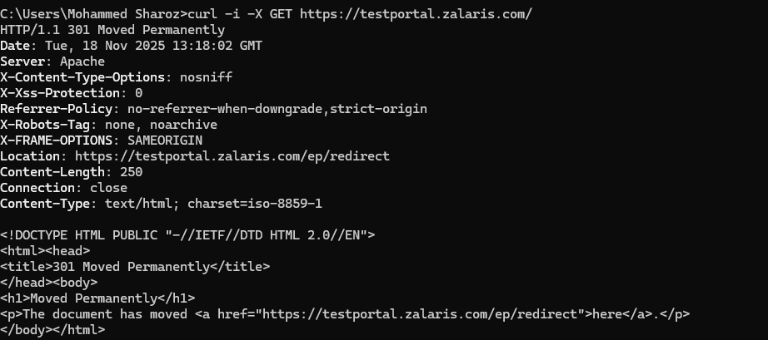

HEAD method to retrieve the headers alone

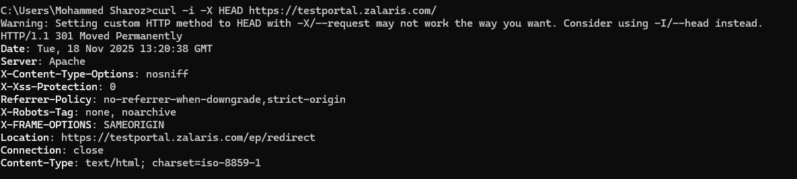

POST method to submit a payload to the server

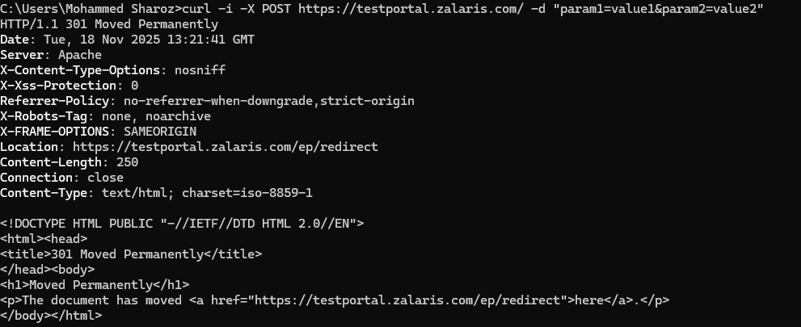

PUT method

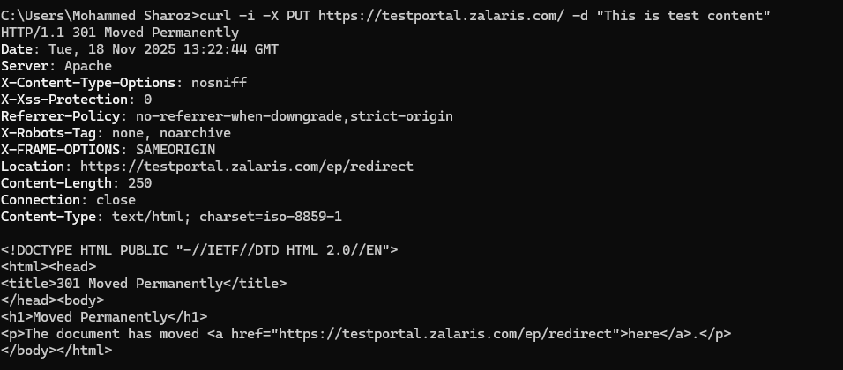

6-DELETE Method - attempt to delete resource

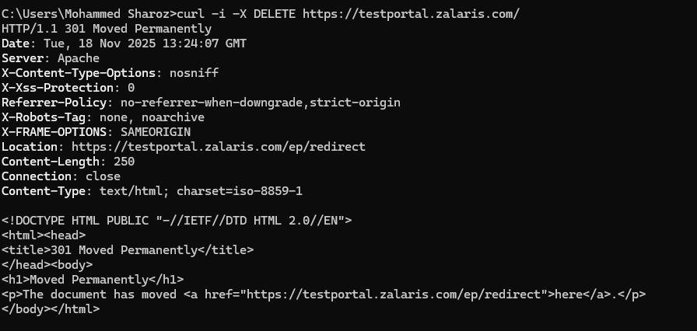

7-PATCH Method - attempt partial update
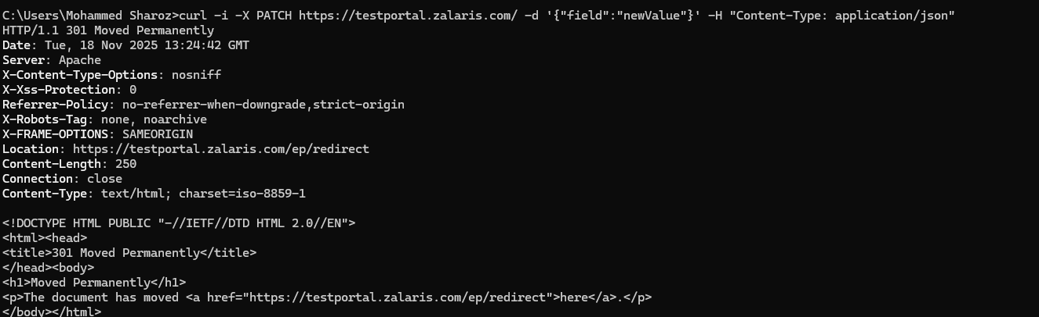
TRACE Debugging Echo Request

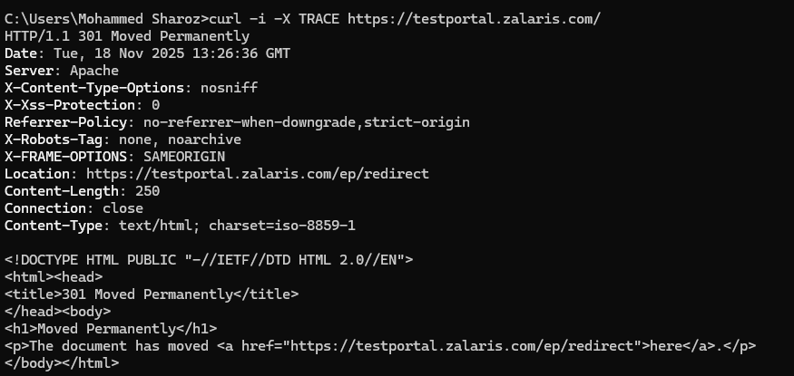

Supporting screenshots [authenticated requests]

Targeted IP : 91.203.116.23

1-OPTIONS method to discover allowed methods. No information on allowed methods is received in the response

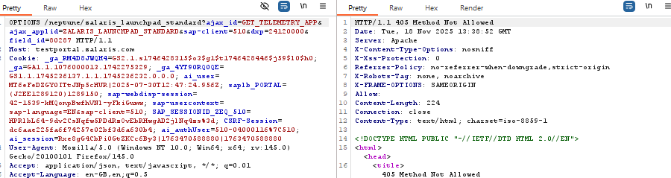

GET request to retrieve resource

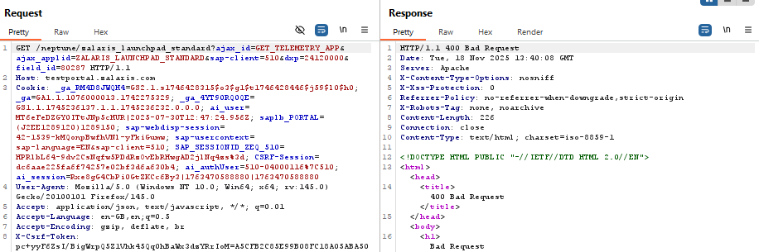

HEAD method to retrieve the headers alone

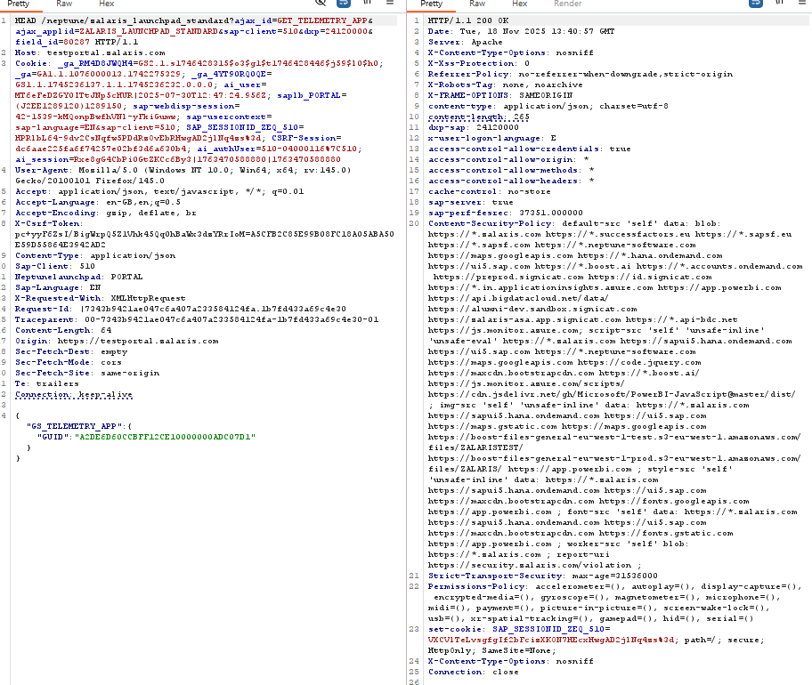

Potential Issue : access-control-allow-credentials set to “true” . Should be tested for exploitation

4- POST – Submit data

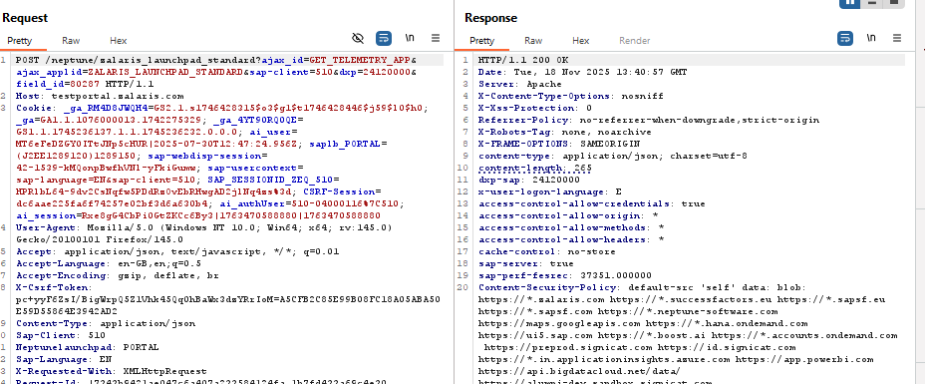

Potential Issue : access-control-allow-credentials set to “true” . Should be tested for exploitation
Access-control-allow-origin and access-control-allow-credentials together must not be set

5-PUT – Attempt to replace resource

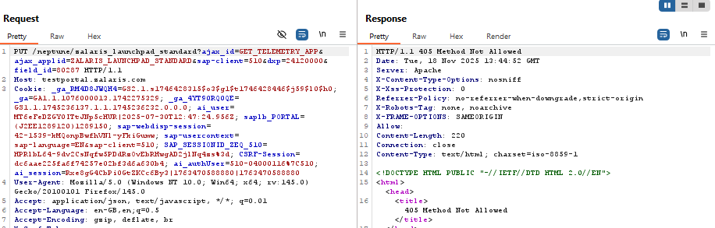

6-DELETE – Attempt to delete resource

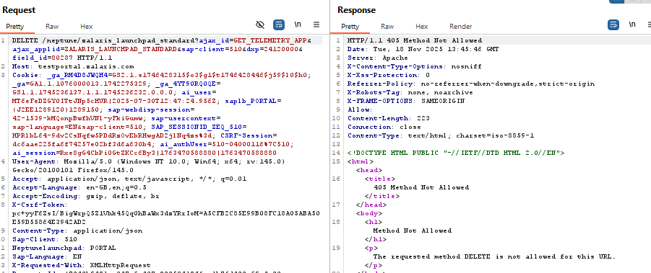

7-PATCH – Attempt partial update

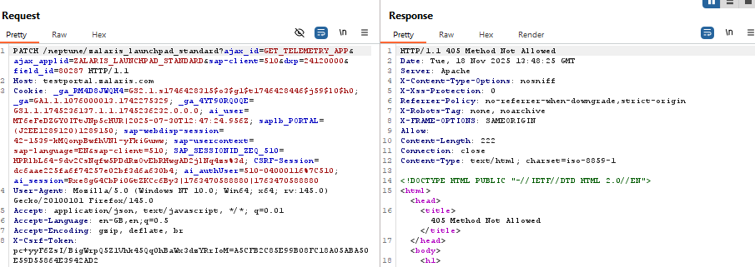

TRACE – Debugging echo request

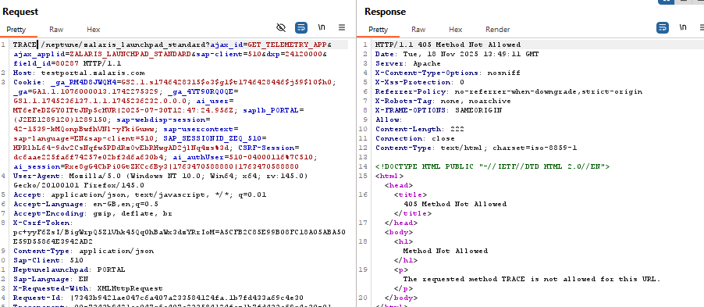

Supporting screenshots [Unauthenticated requests]

Targeted IP : 20.16.233.127

1-cURL request with OPTIONS method to discover allowed methods. No information on allowed methods is received in the response

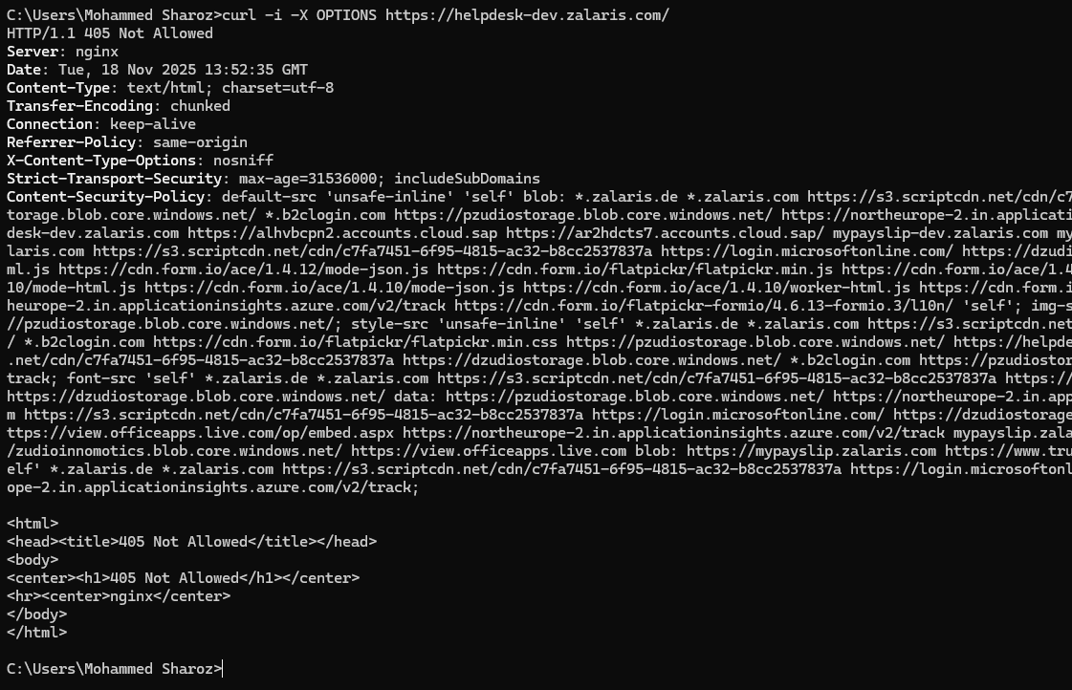

2-cURL GET request to retrieve resource. Received 301 Moved permanently response
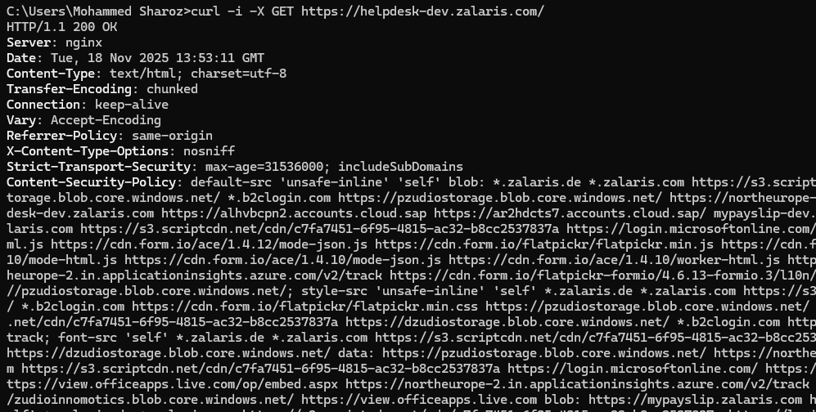

3-HEAD method to retrieve the headers alone

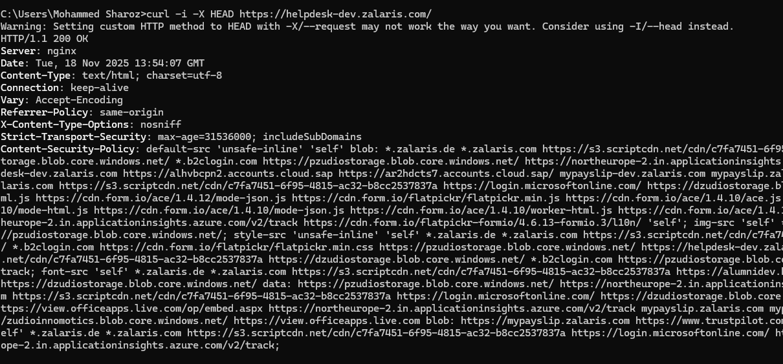

The response from server is not completed and is kept alive in terminal checking further

4-POST method to submit a payload to the server

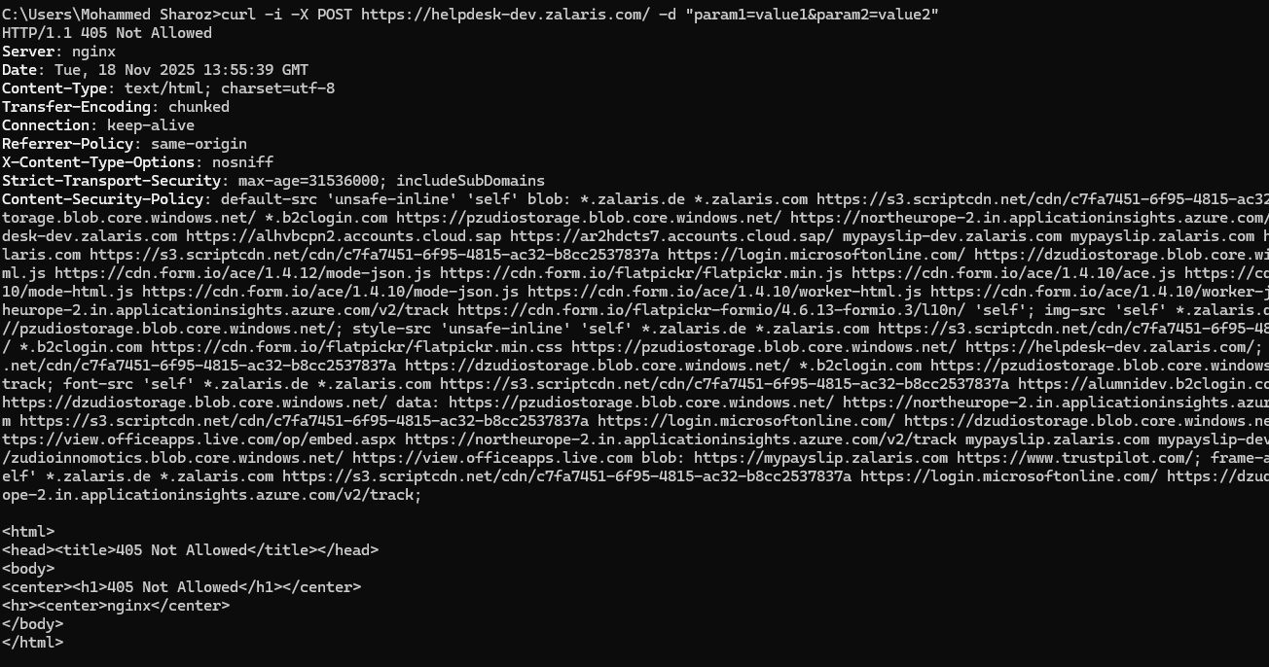

5-PUT method

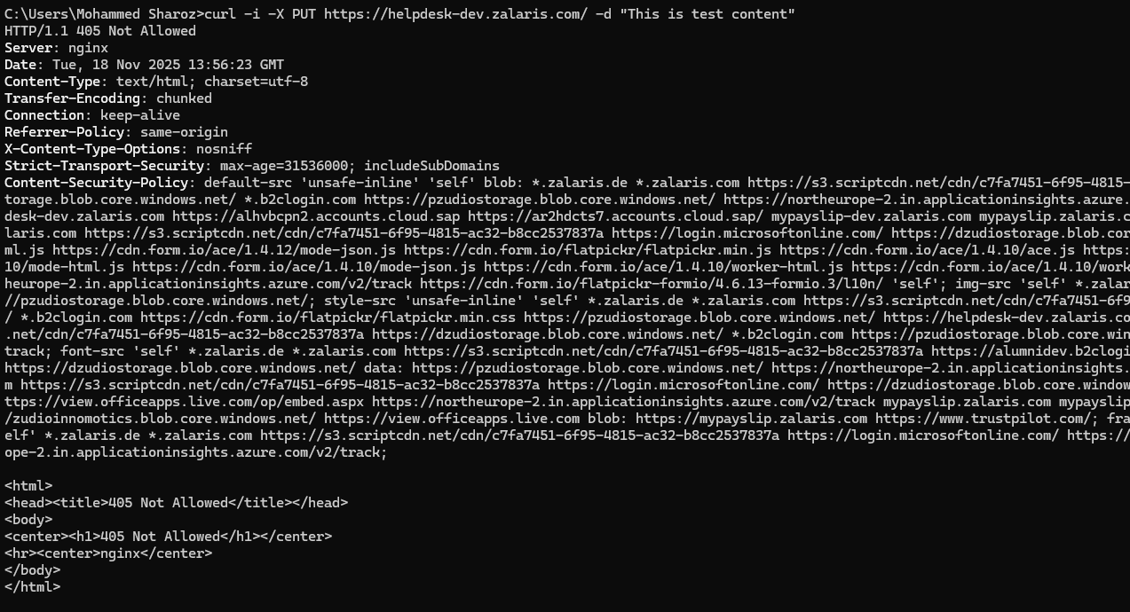

6-DELETE Method - attempt to delete resource

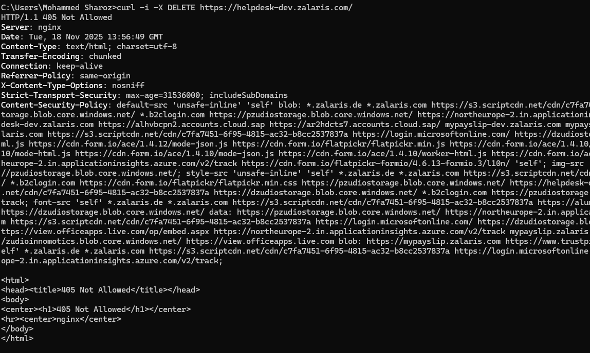

7-PATCH Method - attempt partial update
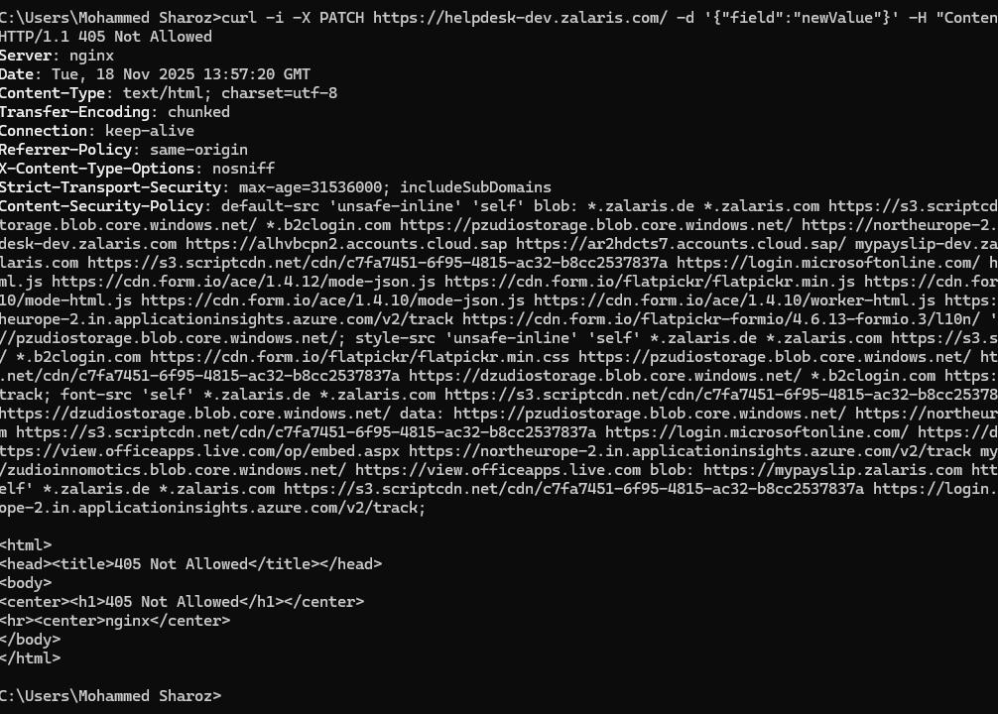
8-TRACE Debugging Echo Request

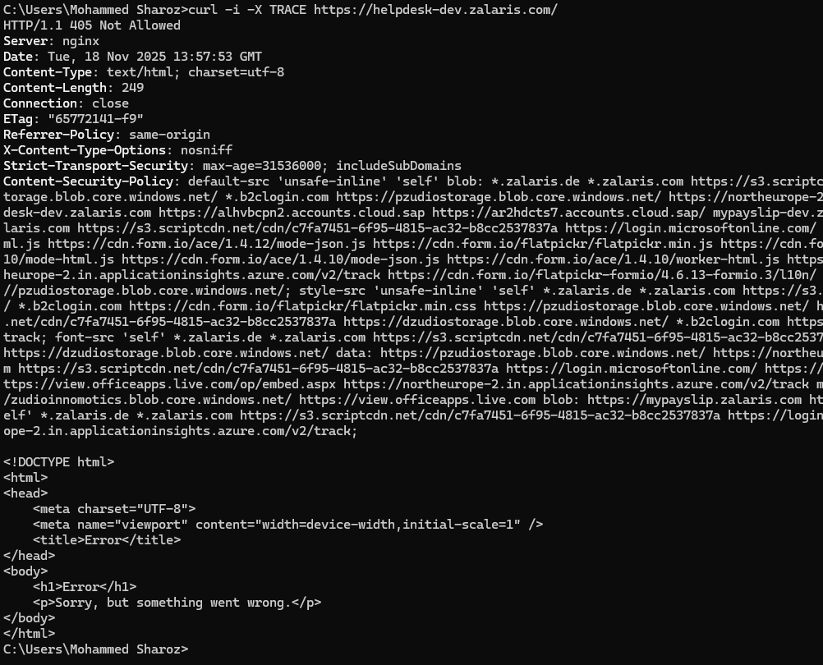

Supporting screenshots [authenticated requests]

Targeted IP:20.16.233.237

1-OPTIONS method to discover allowed methods. PUT and OPTIONS are allowed

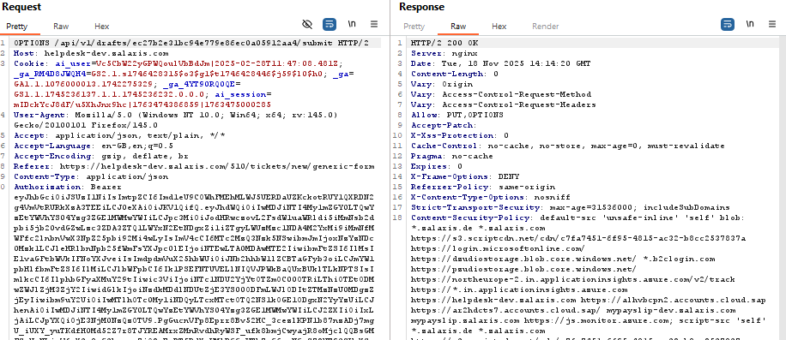

2-GET request to retrieve resource

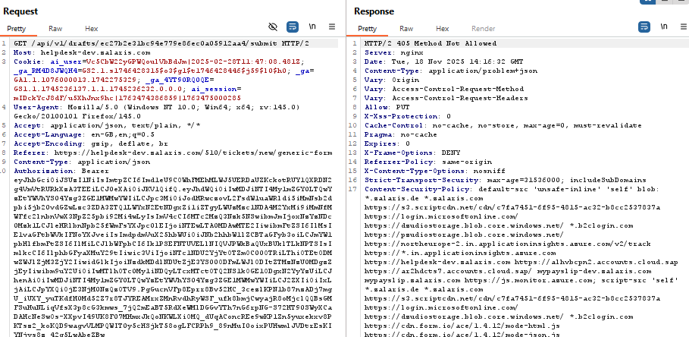

3-HEAD method to retrieve the headers alone

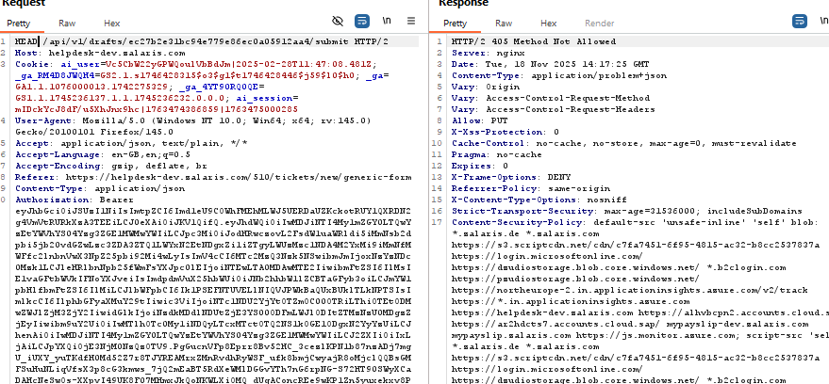

4- POST – Submit data

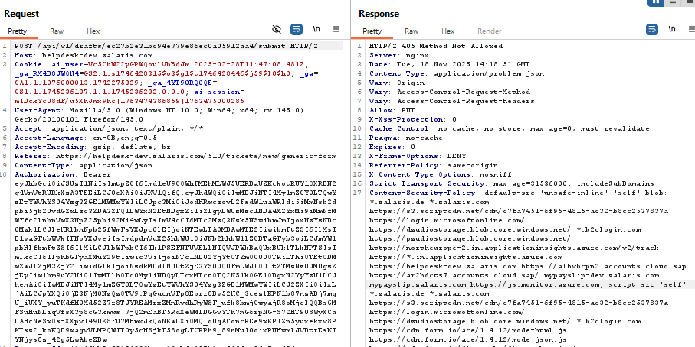

5-PUT – Attempt to replace resource

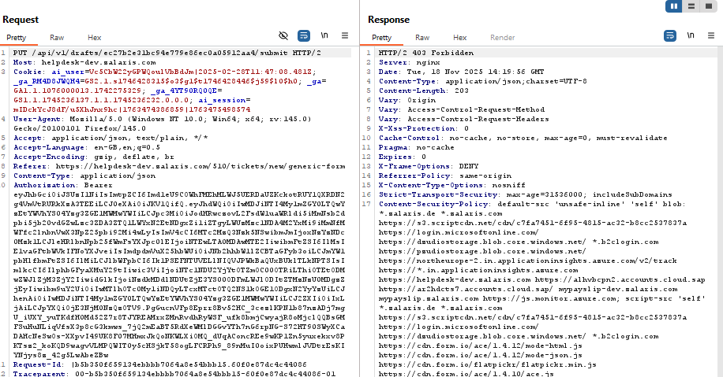

6-DELETE – Attempt to delete resource

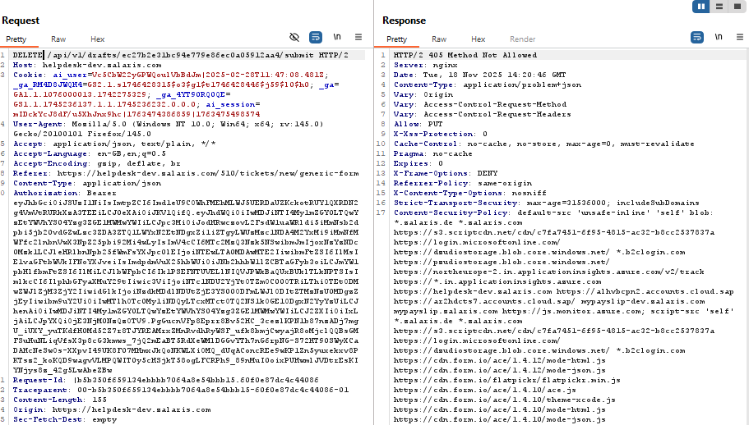

7-PATCH – Attempt partial update

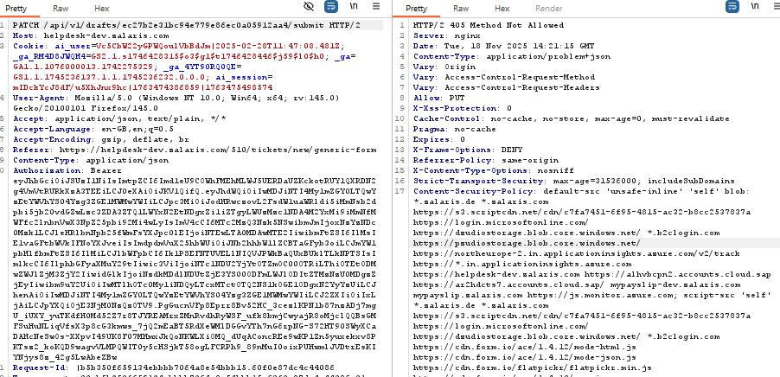

8-TRACE – Debugging echo request

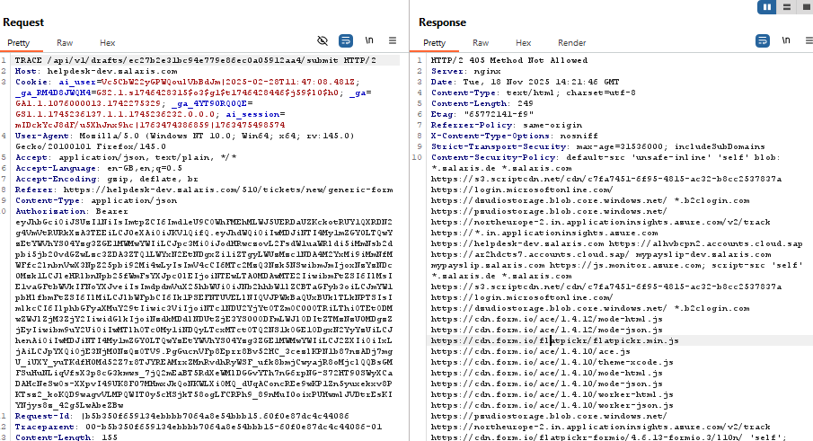

Supporting screenshots [Unauthenticated requests]

Targeted IP : 185.201.93.198

1-cURL request with OPTIONS method to discover allowed methods. No information on allowed methods is received in the response

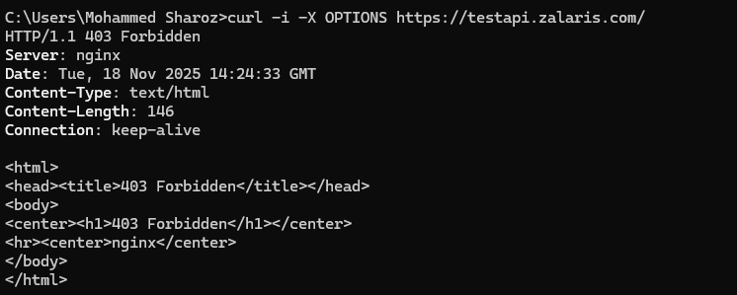

2-cURL GET request to retrieve resource. Received 301 Moved permanently response

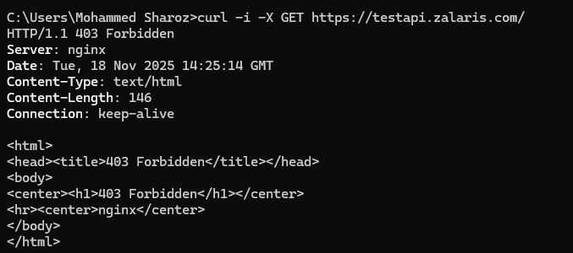

3-HEAD method to retrieve the headers alone

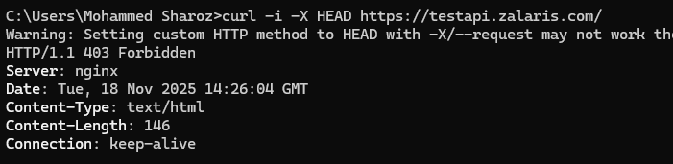

4-POST method to submit a payload to the server

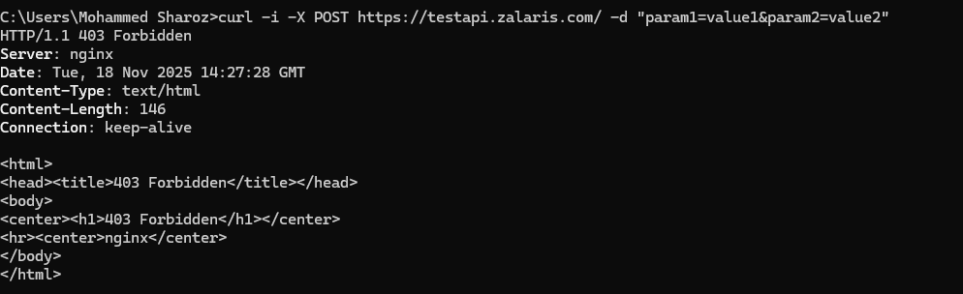

5-PUT method

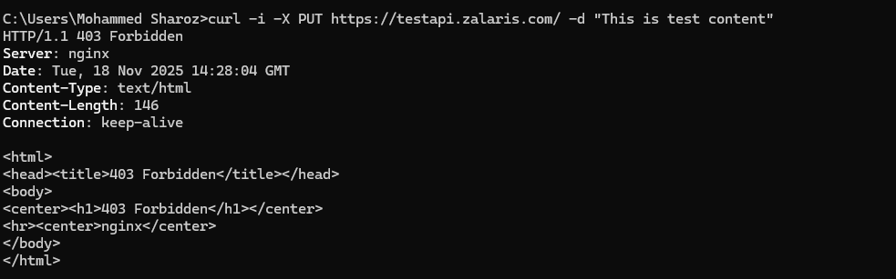

6-DELETE Method - attempt to delete resource

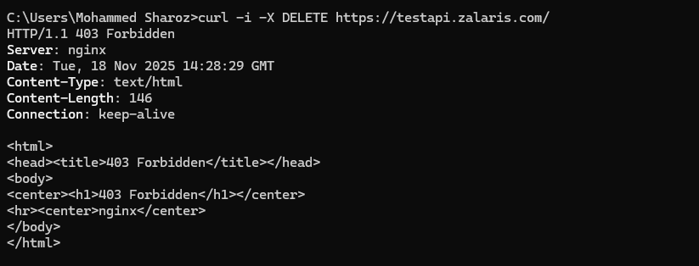

7-PATCH Method - attempt partial update
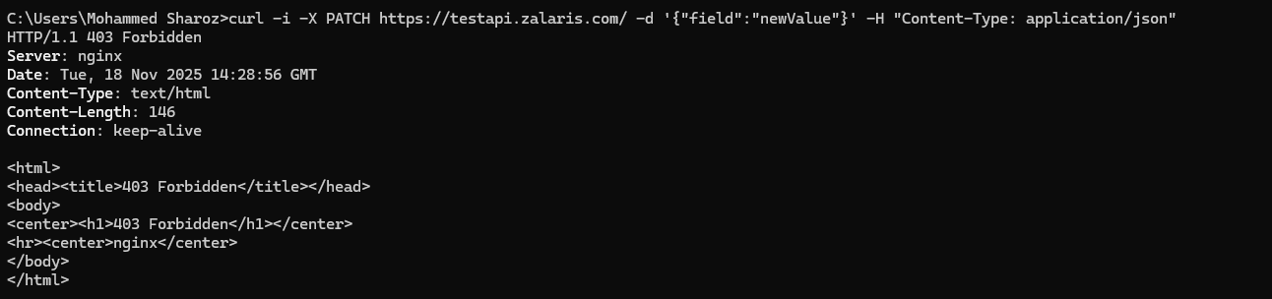
8-TRACE Debugging Echo Request

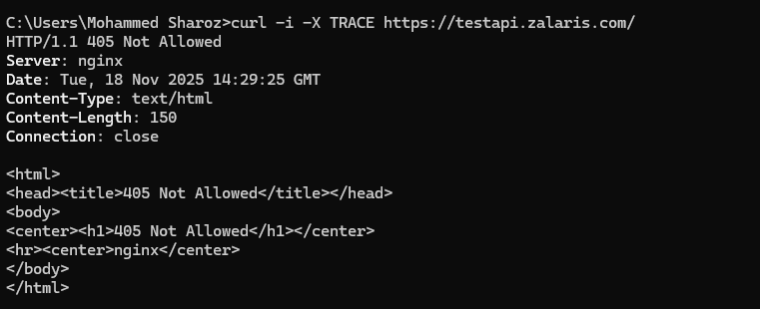

For testapi.zalaris.com - authenticated tests are not possible at the moment

Recommendation

- Restrict HTTP methods to only those required for application functionality (typically GET and POST).
- Disable or block TRACE and OPTIONS unless explicitly needed.
- Implement proper authentication and authorization checks for methods like PUT, DELETE, PATCH.
- Regularly review server configuration to ensure unnecessary methods are not exposed

WORKLOG

When | What | Who | Recommended Action
18 November 2025 | Enumeration or HTTP methods against the following servers 91.203.116.23 , 20.16.233.237 , 185.201.93.198 | Mohammed Sharoz | No issues with TRACE method found.  Access-control-allow-credentials and access-control-allow-origin are enabled in testportal - must be tested for exploitation

